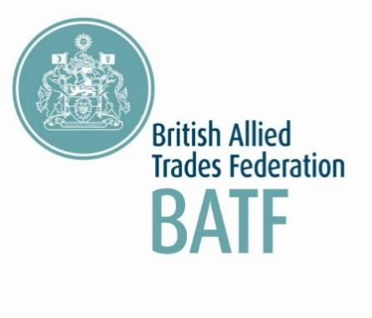
Charity funding application
The British Allied Trades Federation (BATF) plan to donate £50,000 during 2025 to nominated charities. Applications will be shortlisted by the BATF Charity Committee, and the recipient(s) of the funding will be decided by the BATF Board of Directors. More than one charity may be chosen to receive the funding, in this case the funding will be shared.
Applications will be accepted from the following:
- Nominations for a chosen charity to receive funding
- Charities directly requesting funding to support their activities
Please note that we can only accept applications regarding registered charities, all charity registrations will be verified, and funds will be paid directly to the registered charity’s bank account.
The deadline for applications is 1st May 2025. Applications for funding between £500 and £5000 will be considered.

Your name:
Your company name:

Telephone number:

Email address:
Email address

Your chosen charity (including Charity Registration Number if known):
Point of contact at the charity (if not yourself):

Charity’s website (if applicable):

Please indicate which type of funding you are applying for (tick as appropriate):
Nominate my chosen charity to receive funding
I would like to request funding for a charity that I work for

Please provide a brief overview of your chosen charity:

Please provide details of your funding request including the amount of funding required (where possible) and how it will be used:

Please indicate how you know the charity/if you have any personal experience of the charity and why you think it deserves the funding:

